# **Outlook of Machine Learning**

## ****“ A breakthrough in machine learning would be worth ten Microsofts. ”****

## ****— Bill Gates****

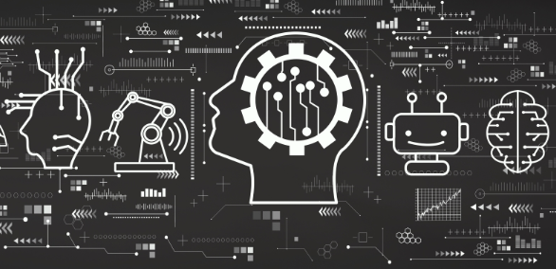

First thing that strike in mind when we hear the word “Machine Learning” is a robot : a dependable butler or a deadly Terminator. But let me tell you that Machine Learning is no longer a futuristic fantasy, it’s already in action. First Machine Learning program was a *spam filter* backs in *1990s*which had actually learned so well that we don’t have to decide whether an email is spam or not anymore. It was followed by hundreds of ML applications which we use regularly from better recommendations to voice search.

So where does Machine Learning really starts and where does it ends? What exactly it means for a machine to *learn* something? Will it get suddenly smarter when I download a copy of book, has my computer really *learned* something? Here I will start by clarifying what is Machine Learning and why we want to use it. Then we will be all set to explore the Machine Learning continent. Let’s begin:)

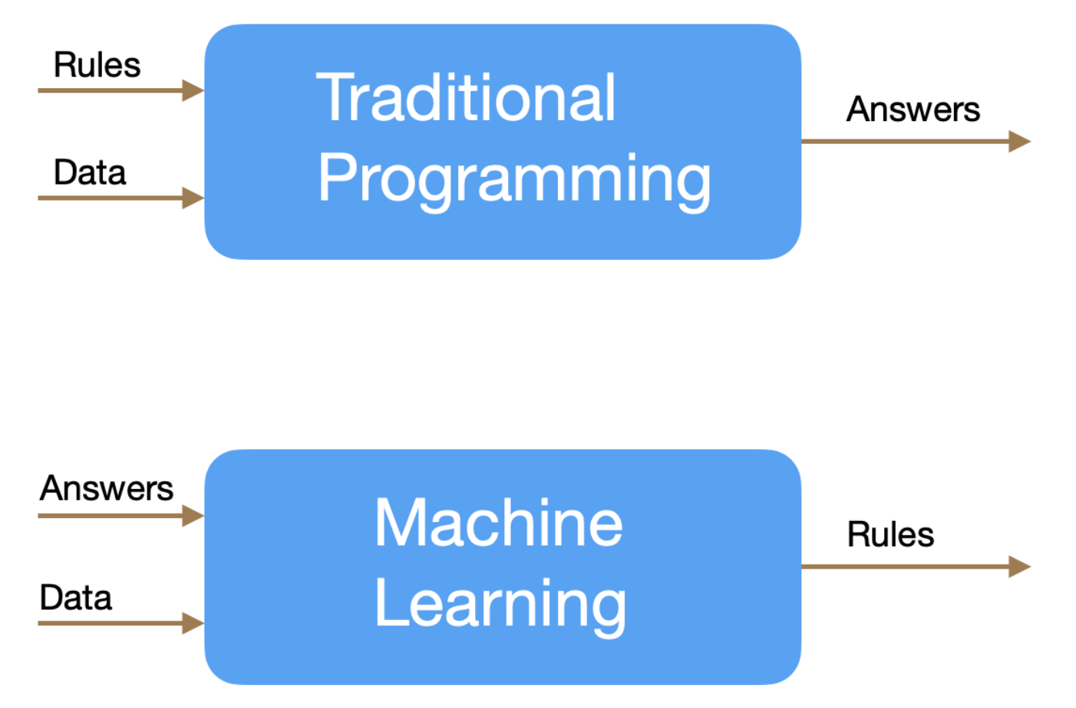

# ****What is Machine Learning ?****

Machine Learning is the science ( and art ) of programming, computers so they can learn from data provided.

More general definition would be :

“ It is field of study that gives computers the ability to learn without being explicitly programmed. ”

— *Arthur Samuel, 1959*

More engineering view definition would be :

“ A computer program is said to learn from experience E with respect to some task T and some performance measure P, if it’s performance on task T as measured with P is improved with experience E. ” — *Tom Mitchell, 1997*

For example, your spam filter is a Machine Learning program that can learn to mark an email as spam from examples of spam emails (marked by users) and examples of non-spam email (ham email). So here examples which program uses to learn are know as *training set*. Each training example is a *sample* in training set. Here task T is used to mark new emails as spam, experience E is training set and performance measure P needed to be defined (ratio of correctly classified emails). So performance measure P is often called *accuracy* of your program.



# Why use Machine Learning?

Consider how you would write a spam filter using traditional programming approach :

1. First you would look at spam email and you might notice that words like “free”, “discount”, “amazing ” and “4U”. Perhaps you would notice other patterns like email’s body, sender’s email and so on.
2. Now you would an algorithm that detect this patterns and marks an email as spam or not.
3. You would test your program and repeat step 1 and 2 until it is good enough.

Since the problem is not trivial, your program will end up with long list of complex rules which are hard to maintain. Moreover, if spammer notice that email with “4U” are blocked then they might start writing “For U” instead. Here we need to update your program to detect “For U” also. If spammer keep working around your spam filter, we will need to update your program with new rules forever.

In contrast, Machine Learning approach will automatically detect that “For U” has become unusually frequent in spam emails marked by users and now it will automatically mark email as spam without your intervention. Another area where Machine Learning shines is for problems that either are too complex for traditional approaches or have no known algorithm. For example, speech recognition or self driving car.

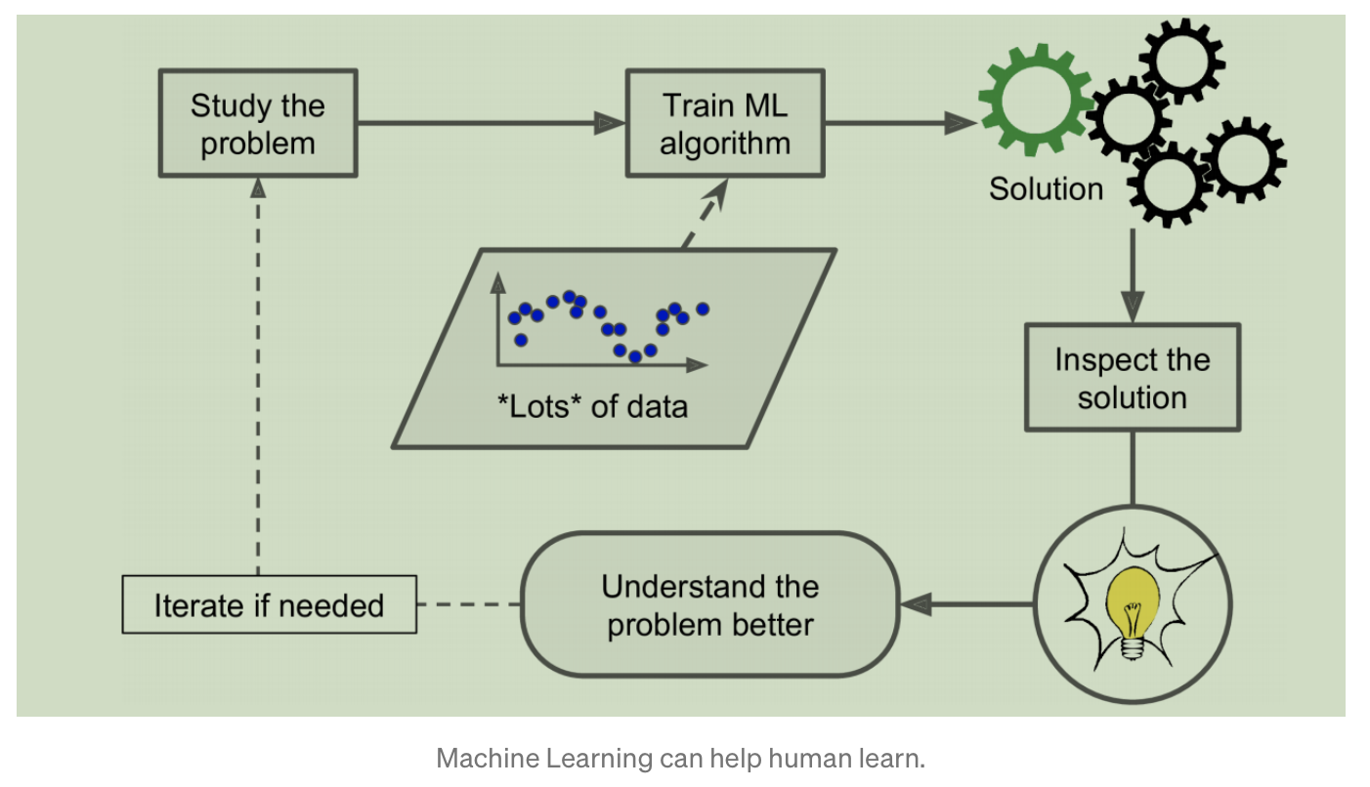

Finally, Machine Learning can help humans learn ML algorithms can be inspected to see what they have learned. Applying ML techniques to dig into large amounts of data can help discover patterns that were not immediately apparent. This is called *data mining*.

Contact Links :-

Twitter : https://twitter.com/jasanidarsh3

LinkedIn: https://www.linkedin.com/in/darsh-jasani

Github: https://github.com/darshjasani

Email ID : jasanidarsh3@gmail.com